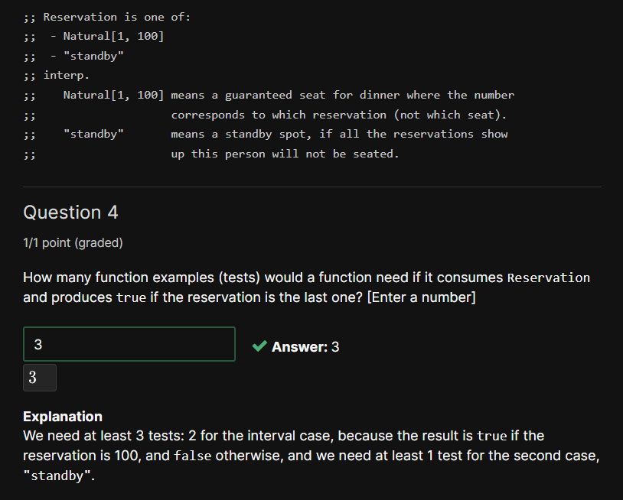

Interval – 2 test cases, atomic distinct – 1 test case

Always put the guards first!

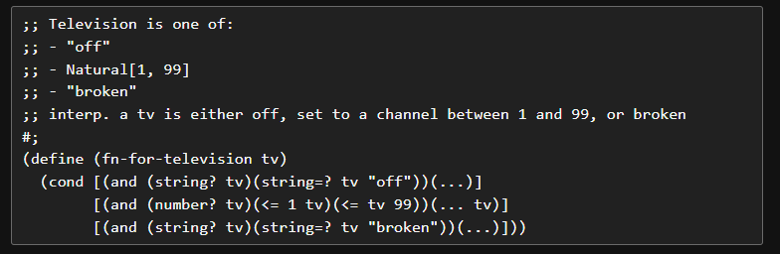

After simplification:

